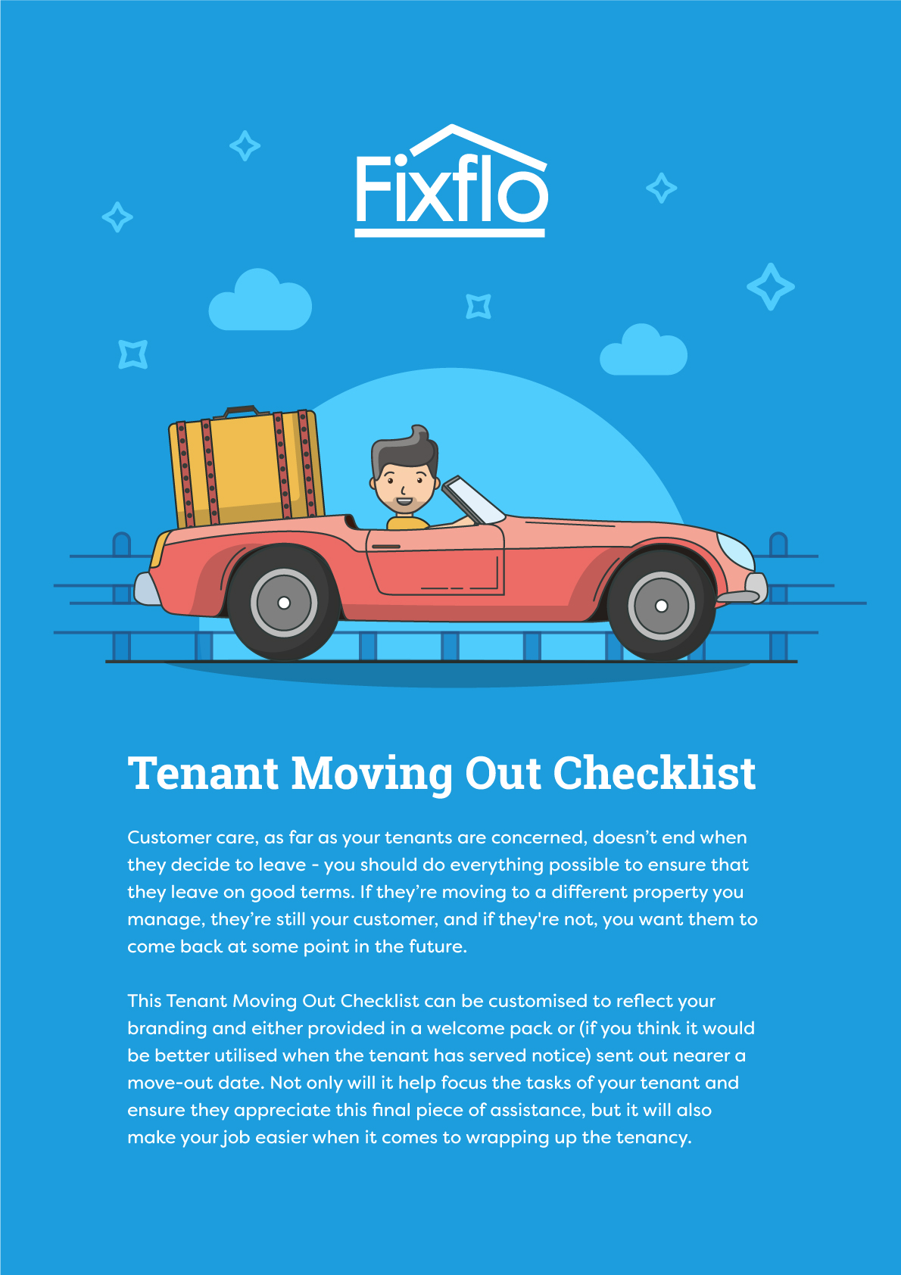

Council Tax & Utilities  As far as utilities are concerned, most providers should allow you to switch addresses relatively easily, though there may be short delays if phone lines or other hardware needs to be installed at your new property. After you’ve moved out, you can provide final meter readings if necessary. | 
Check with your landlord before ending the service you receive from any provider.

Have you contacted your local council tax authority to inform them of your change of address?

Have you contacted your water supplier to let them know you’re leaving?

Have you contacted your telephone and broadband supplier to let them know you’re leaving?

Have you contacted your gas supplier to let them know you’re leaving?

Have you contacted your electricity supplier to let them know you’re leaving?

Have you notified your TV license provider to let them know you’re moving?

Address Change
Have you notified everyone who needs to be notified of your change of address? Possible people and organisations include:

Your bank

Your insurance provider(s)

Your GP, dentist and other relevant medical practitioners

The DVLA (for motor insurance and driving license)

Your mobile phone provider

Service providers who need your address (i.e. magazines, Amazon, etc)

Royal Mail (when setting up a redirect service to cover your first few months in your new home)

HMRC

Your building society

Your workplace

Property Conditions
The property should be as clean and clear as possible by the time you come to move out - this is where disputes occur most often. You may wish to hire an end-of-tenancy cleaning service to make extra sure, though you’re under no obligation to do so.

The main tasks are listed here:

Are the kitchen appliances (including oven, hob and microwave) spotless?

Have you defrosted the freezer?

Have you wiped out all cupboards to get rid of dust?

Have you covered up any scuff or dirt marks on the walls or doors by repainting or cleaning?

Have you washed the inside of the windows (and hired a window cleaner for the outside windows you can’t reach)?
Is the garden tidy (depending on the time of year)?

Have you steam-cleaned (or at least vacuumed) rugs and carpets?

Have you vacuumed and/or washed furniture upholstery?

Keys
Have you labelled all the keys for easy identification?

If there are any missing, have you notified the property manager?

The Week Before The Move
Have you bought or borrowed enough boxes, newspaper, masking tape, pens and bubble wrap for everything you need to take with you?

Have you hired a moving van?

Have you enlisted help to pack?

Have you put aside the belongings you’ll need throughout moving day and on the first night in your new home?

Have you checked out the parking situation outside your new property and saved a space for the van if possible to ensure it doesn’t have to park round the corner?

On Moving Day
Have a good breakfast

Have you made a final sweep of the property and made sure it’s as clean as possible?

Have you ensured all main valves are off (including the main power switch at the fuse box)?

Have you ensured all appliances are shut down and unplugged?

Have you locked all windows and doors?

Have you taken photographs where necessary if you think you may require proof of conditions?

Have you sorted out childcare and petcare for the day?



