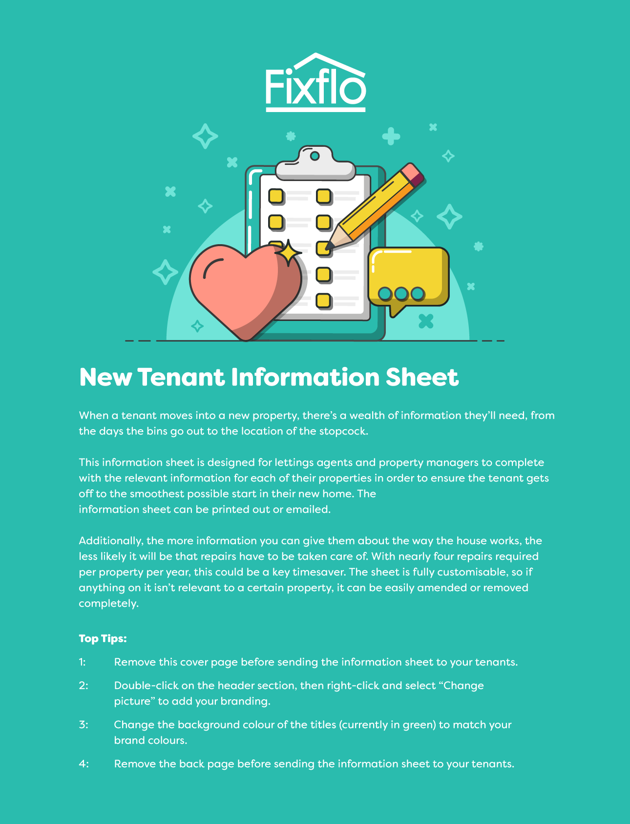

Hi! Welcome to your new home!

This sheet should provide you with all the vital information we can think of, whether it’s the location of the stopcock or the emergency contact details we hope you’ll never require.

If there’s anything you’re not sure about or anything you want clearing up, don’t hesitate to get in touch.



Address

Your full mailing address is:

Your local council is:

Rent and deposit

The rent is due on:

The scheme your deposit is protected under is:

Documents

You should have the following documents:

- A Gas Safety Certificate
- Deposit protection paperwork
- An Energy Performance Certificate
- An up-to-date copy of the Government’s How to Rent guide

If you are missing any of those documents, please get in touch with us as soon as possible.

Utilities

The stopcock to shut off the water is located:

The fuse box is located:

The gas and electricity meters are located:

The smoke alarm is located:

The carbon monoxide detector is located:

The TV aerial socket is located:

The phone line socket is located:

The thermostat is located:

The broadband is provided by:

The landline is provided by:

The heating is provided by:

Bins

The main rubbish bin is collected on:

The recycling bin is collected on:

Repairs

You can use Fixflo’s 24/7 repair reporting portal to alert us to any repairs that might be required. It’s available in over 40 languages and is picture-based so we can see exactly what the problem is. | https://youragency.fixflo.com

Contact details

Your property manager is:

Email:

Phone number:



