Mental Health Flyer for tenant welcome pack

Mental health is an ongoing issue in today’s society. Approximately 1 in 4 people in the UK will experience a mental health problem each year. In England, 1 in 6 people report experiencing a common mental health problem (such as anxiety and depression) in any given week.

This flyer is designed to go out with your tenant welcome pack, along with other pertinent tenancy information for them. It may seem like a simple idea but increasing awareness of the help that’s available for those suffering from mental health issues is a great first step towards better helping them.

The flyer covers:

- The Samaritans helpline
- Other useful helplines

Simply add your logo to the flyer and include it as a part of your welcome pack, removing this page and the final page of this document.

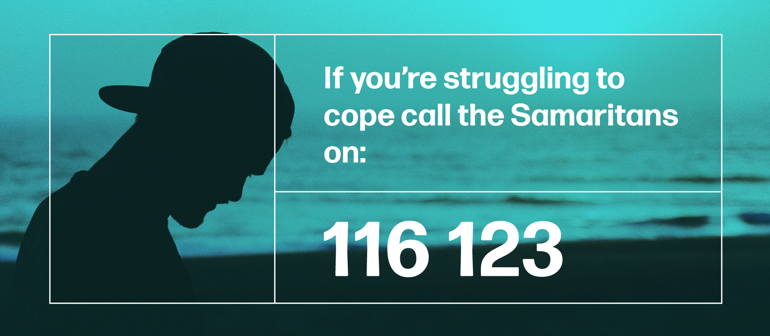
The Samaritans offer confidential support for anyone experiencing feelings of distress or despair. This number is free to call, 24 hours a day, 7 days a week.

Or email jo@samaritans.org

Other support numbers are:

Campaign Against Living Miserably (CALM) – for men
Call 0800 58 58 58 – 5pm to midnight every day
Childline – for children and young people under 19
Call 0800 1111 – the number won't show up on your phone bill
The Silver Line – for older people
Call 0800 4 70 80 90

