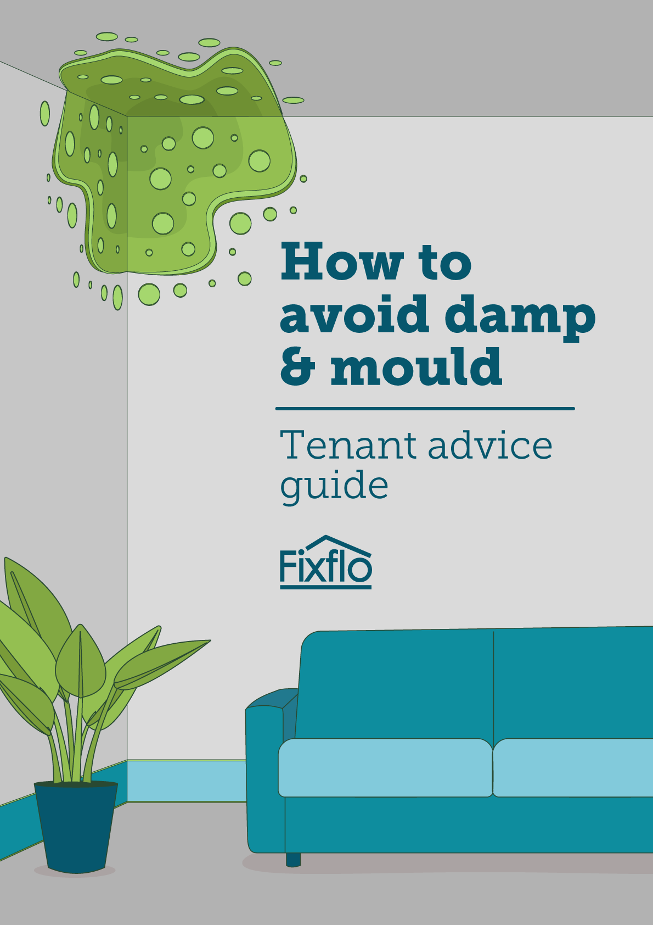

Damp and mould can make a home really unpleasant to live in and can even potentially create health issues. You will probably have come across at least one instance of damp or mould in a property you manage so you understand how it affects the lives of those who live there.

The Homes (Fitness for Human Habitation) Act is now law and includes as part of it the Human Health and Safety Rating System (HHSRS) which covers whether a home is fit for people to live in. One of the hazards covered in this is damp and mould, so ensuring it’s correctly treated is important both for quality of life of tenants and from a legal perspective.

We’ve already covered what you as a letting agent can do in our guide “Damp & mould: What are your responsibilities?” which you can download here. It covers where legal responsibility lies.

But you can also educate your tenants about how to avoid damp and mould before it becomes an issue and what to do if it does. This guide is designed to be given to your tenants when they move in to your property and covers:

- The different types of damp and mould
- How to prevent it from happening
- How to treat it

Just remove the front pages and the final page and give this checklist to them to use.

How to prevent damp and mould

Welcome to your new home! We hope you’ll be very happy here and in order to ensure you’re able to fully enjoy it, you’ll want to keep it free of damp and mould. We’re sure you're already aware of most of these suggestions but it’s always worth having a refresh!

There are three types of damp that typically appear in homes:

Condensation
Generally condensation isn’t something to worry about, it’s normal for it to appear on cold windows overnight in a bedroom or while the heating is on. It’s caused when the air indoors can’t hold any more moisture. However, if you find it’s happening constantly or on cold walls it could potentially create mould. There are key areas in homes where this can happen, mainly the kitchen and the bathroom.
Here’s what you can do to avoid condensation:

Be aware that if you can turn a ventilator on you must do so when:

  Cooking |   Showering/bathing |   Drying clothes inside

You can help to avoid condensation forming by doing the following:

- Opening your bedroom window for 15 minutes every morning to allow it to dissipate
- When cooking put lids on your saucepans
- If you can then dry washing outside, if you can’t make sure the window is open or that the room you’re drying them in is well ventilated.
- Avoid drying clothes in rooms where they take a long time to dry
- Make sure you’re regularly ventilating rooms by leaving the doors open to circulate air
- Unless you’re cooking in which case open a window, put the fan on and shut the door.

If you do have an issue with mould:

Only remove mould yourself if it's caused by condensation and covers an area less than 1 metre squared (1x1 metre or 3x3 feet) in total. If it’s more than this please report it to us. This advice is quoted from the NHS website:

- Fill a bucket with water and some mild detergent, such as washing-up liquid or a soap used for hand-washing clothes
- Use a rag dipped in the soapy water to carefully wipe the mould off the wall. Be careful not to brush it, as this can release mould spores
- When you've finished, use a dry rag to remove the moisture from the wall
afterwards, put the rags in a plastic bag and throw them away
- All the surfaces in the room should be thoroughly cleaned by either wet wiping or vacuuming to remove any spores

The other types of damp are:

Penetrating damp

Penetrating damp generally occurs when there is an internal leak or plumbing issue within a
property, with water coming through the walls or roof.

Rising damp
Rising damp is a problem most often found in older houses, where moisture in the earth below it is drawn up into the bricks or concrete at the bottom of the house.

If you see either of these please report it to us as quickly as possible so we can look into it.

By following these simple tips you’ll avoid one of the main causes of damp and mould! We hope you’ll be very happy in your new home.

