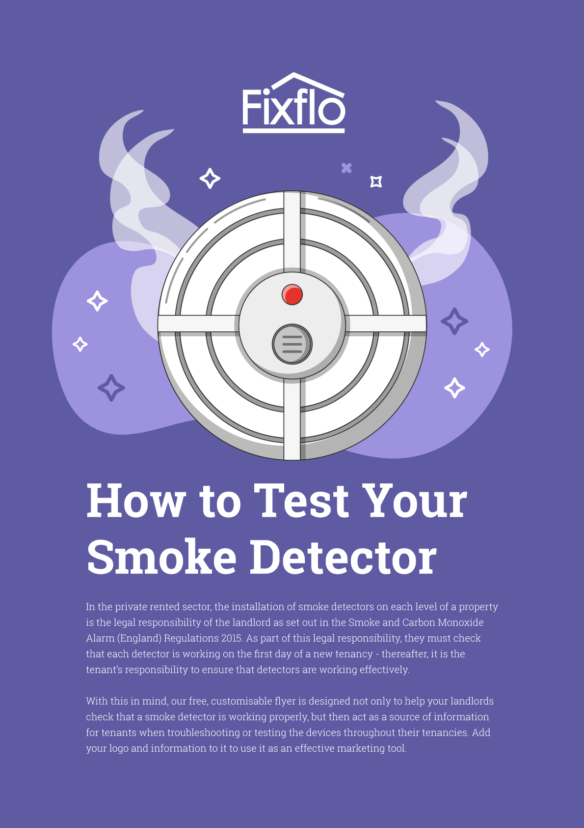

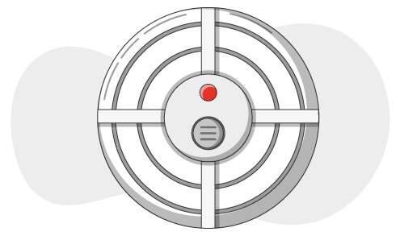

How to Test Your Smoke Detector
Smoke detectors require little maintenance, but that maintenance could be life-saving. Although there are several makes and models that you might have, you can test their effectiveness in one of two ways.
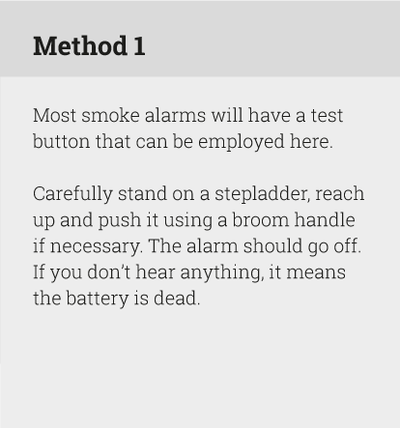
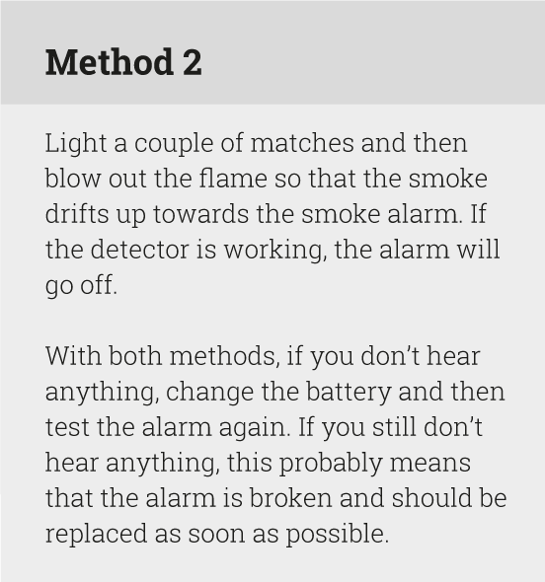

How often should I test a smoke alarm?
Some people recommend testing it once a month; some recommend testing it when the clocks change. It’s up to you - test your alarms as often as you feel comfortable doing so.

General smoke alarm maintenance
- Clean dust away wherever necessary
- Never remove the battery to use in something else because you may forget to replace it
- Replace the battery on an annual basis even if it is still working
- Replace the alarm every ten years or so



