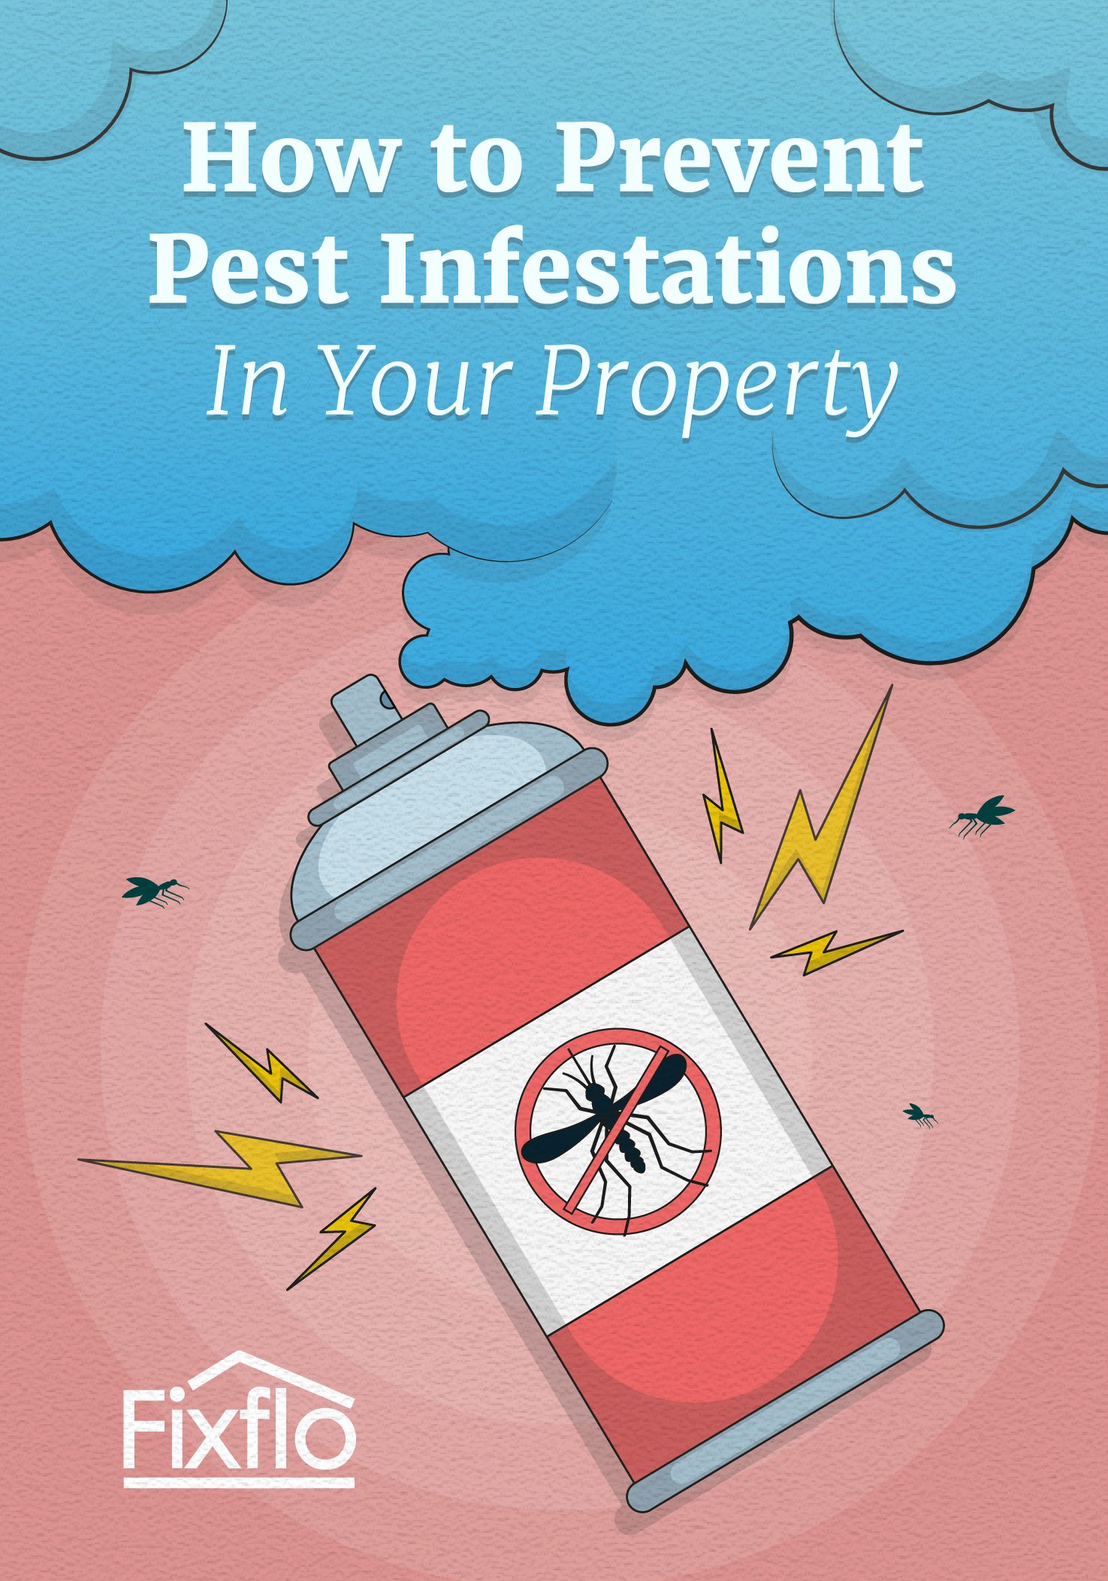

How to Prevent Pest Infestations in Your Property

Pests can create havoc and disruption in any property they infest, regardless of how they get in. If they’re not caught before they’ve had a chance to breed and spread, it can be expensive and time-consuming to get rid of them and ensure that the property is completely pest-free.

Dealing with a pest infestation is often the bane of a property manager’s life, and it’s therefore important that pests are not given the chance to infest a property in the first place, let alone spread. However, it can be difficult to enforce this in your properties given that tenants are the ones living there - if an infestation occurs, it won’t necessarily be their fault (for instance if a dog or cat brings in fleas) but sometimes the infestation will be completely preventable by taking a few simple steps and precautions.

This guide is designed for you to give to your tenants as part of a welcome pack in order to help them prevent pest infestations during their time in the property. It’s full of useful tips and, crucially, explains what the results will be if they don’t follow them - they don’t want to live in an infested property just as much as you don’t want to use up your work time in sorting the infestation out.

The guide covers:

- The interior of the property, including rooms such as the kitchen and bathroom, and the exterior
- Different types of pests to contend with
- The various preventive measures that tenants should be taking

If you have any questions about this guide, don’t hesitate to get in touch.

Hi there,
Welcome to your new home!

In order to ensure you’re able to fully enjoy it, you’ll want to keep it as free of pests as possible. We’re sure most of this will be obvious, but it never hurts to refresh your memory!

If you do suspect you have a pest infestation, let us know as soon as possible so we can begin to resolve it for you.

Which pests do you need to look out for?

Some of the pests that people in the UK commonly have trouble with include:

- Mice | - Fleas
- Rats | - Spiders
- Foxes | - Cockroaches
- Bees | - Ants
- Wasps | - Bedbugs

These pests will cause different problems and vary in terms of the threat to safety they pose depending on potential allergies or phobias. While foxes will probably just go through your bins and be too scared to come near you even if you go outside, a wasp nest could deliver some nasty stings if you disturb it.
Prevention

It’s important that you do everything possible to prevent a pest infestation, both inside and outside the house.

Inside

Food waste should be a key concern inside your home. Crumbs and general food debris around the kitchen or living room should be cleared up and any leftovers should be stored in an airtight container so ants are not attracted to them. In terms of bins and food waste, the bin should be closed or otherwise sealed at all times. When it is full, remove the bin liner and take it to the food waste bin outside.

Cleaning should be something you do to maintain a hygienic home anyway, but if things aren’t particularly clean, pests will breed easily. Make sure that kitchen counters, tables and floors are cleaned regularly to prevent crumbs and food building up. If there is clutter on bedroom floors and in living room, this should be cleared as regularly as possible because they provide hiding places and homes for pests. You should also ensure you vacuum regularly, not just to clean the floors and other surfaces but also to catch pests and their eggs.

Here are some other things you can do to prevent pests taking over your home:

- Fill any cracks or holes in the walls that could provide access for insects or rodents to the inside of your home
- Fix any leaks that might result in standing water
- Check any pets that spend time outside for fleas on a regular basis
- Use over-the-counter pest control products if you suspect that you do have a mouse in the walls or you’re finding a lot of wasps entering the house.

Outside

Given that pests will enter your home from the outside, it’s important not to neglect areas like your garden and shrubbery when taking steps to prevent an infestation.

- If you’re outside, use citronella candles to help keep mosquitoes and wasps away from your garden
- Wood piles and scraps can be a haven for beetles and termites, which you need to keep away from your home. Don’t use wood mulch or chips in your garden if possible, and keep any woodpiles at least twenty feet from your home
- Repair or replace rotted wood shingles on the roof
- Keep any tree branches or bushes well trimmed to keep them away from the house, as they could provide routes inside for pests
- Use a bird feeder tray to catch fallen food, as this can attract rodents



