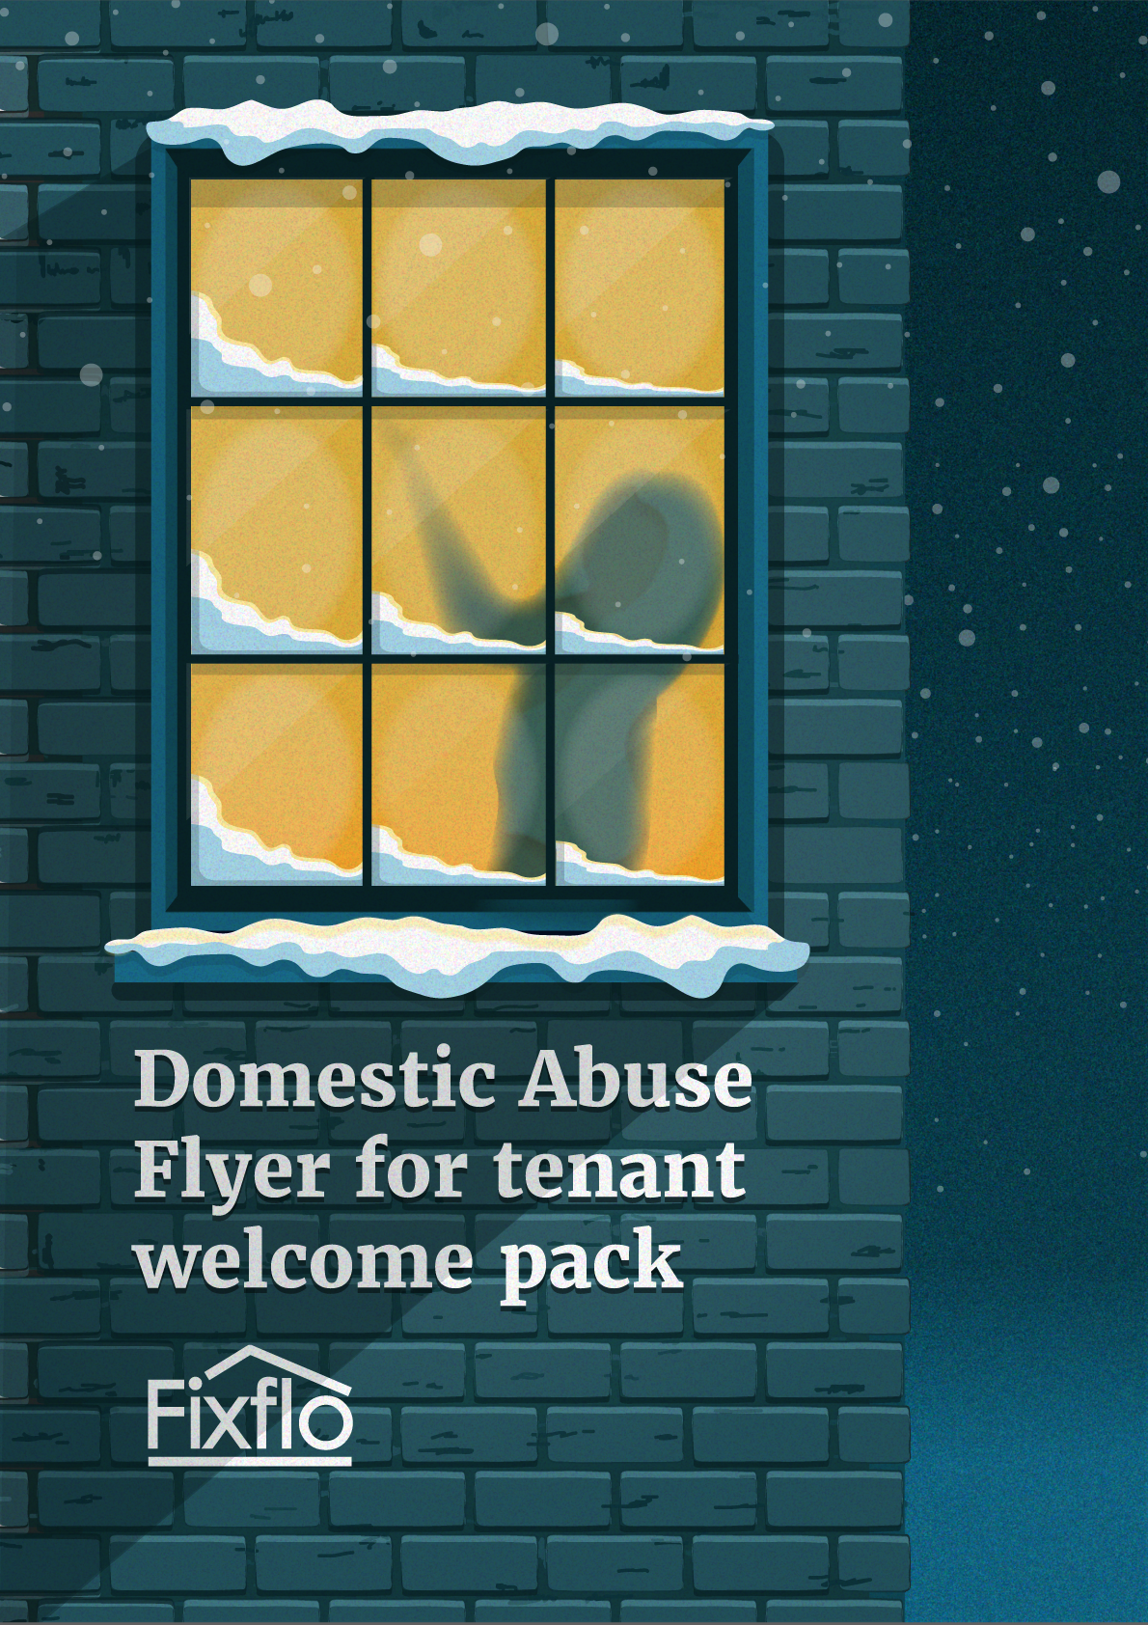

Domestic abuse continues to be a key issue in today’s society - 2 million people suffer from domestic violence every year, a quarter of all women in England and Wales will experience it at some point in their lives. On average 2 women a week die at the hands of their partner - a statistic which hasn’t changed in over 20 years.

In the Fixflo eBook on “Domestic Abuse and the Lettings Industry - how you can make a difference” (downloadable here) we covered exactly what domestic abuse means and why the lettings industry can be a first line of defence.

This flyer is designed to go out with your tenant welcome pack, along with other pertinent information for them. It may seem like a simple idea but increasing awareness of the help that’s available for those suffering domestic abuse is a great first step towards better helping them.

The flyer covers:

- The National Domestic Violence Freephone Helpline
- When to call
- Who can call

Simply add your logo to the flyer and include it as a part of your welcome pack, removing this page and the final page of this document.

Don’t forget you can learn more about how those working in the lettings industry can make a difference by reading our other domestic abuse document by clicking here.
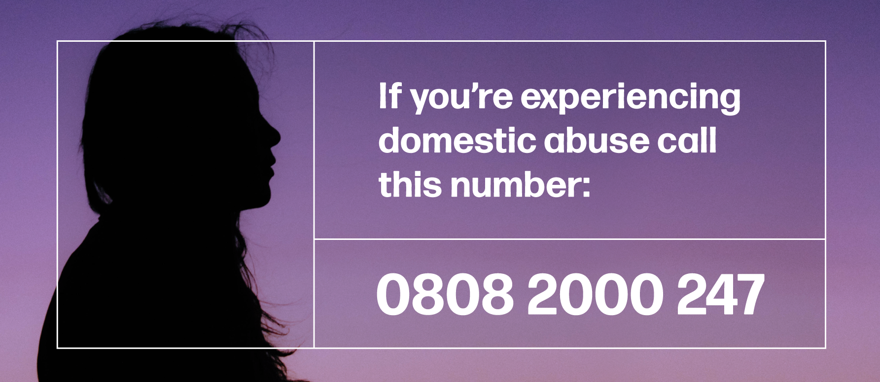
We are a domestic abuse aware business. If you’re frightened of your partner you can call the 24-hour National Domestic Violence Freephone Helpline number above 24 hours a day, 7 days a week.

Or email helpline@womensaid.org.uk

All calls are free from mobiles and landlines. The helpline is run in partnership between Women’s Aid and Refuge. They support survivors of domestic abuse, friends and families. You can also google to find out about other local services and help that’s available.

Before you make the call:

Make sure you are safe before calling the helpline - ensure the perpetrator of the abuse is not in the same property as you (even if they are in another room, the garden or asleep). This is to avoid risk of being overheard.

Have ready:

A pen and paper as the helpline worker may give you telephone numbers for relevant services or refuges, or a reference number. There are local services and help available which the helpline worker will be able to share more information on.

