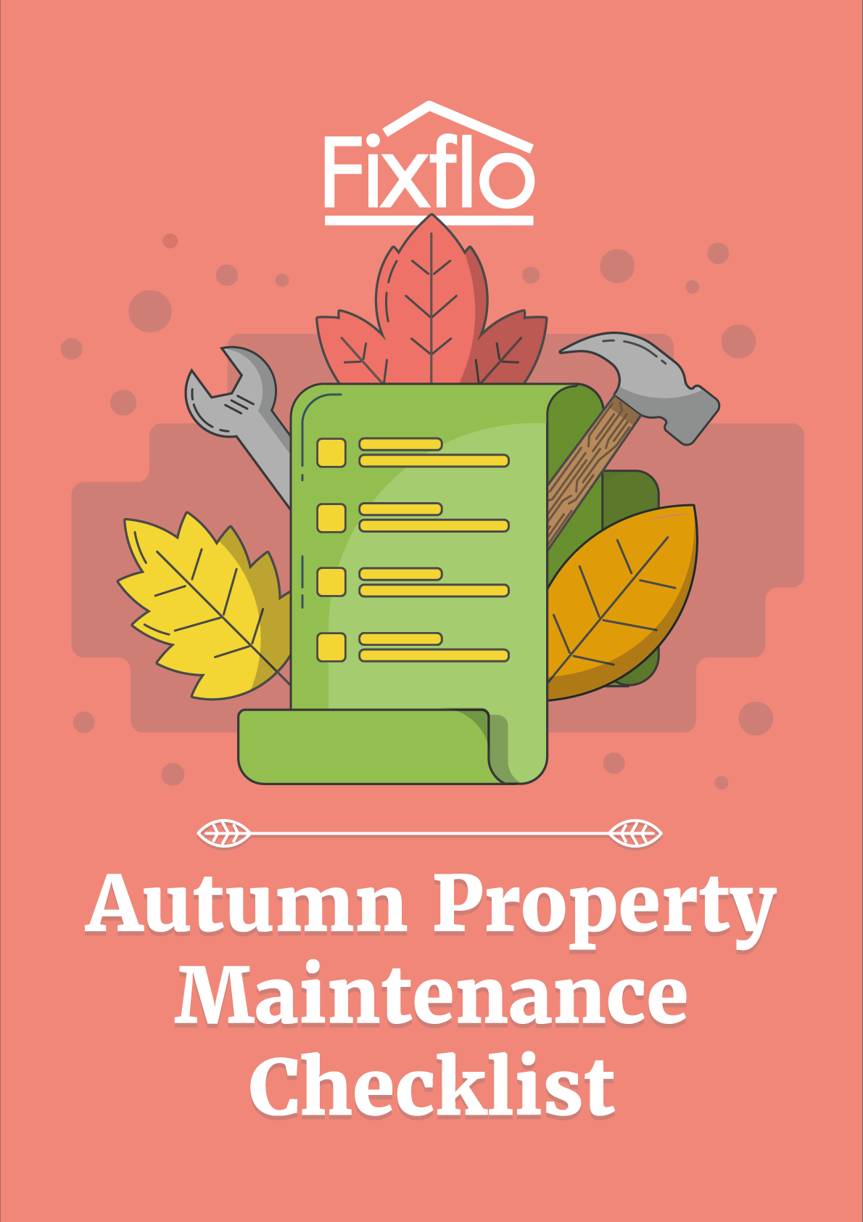

Autumn Property Maintenance Checklist

With temperatures dropping further with every passing day, this is the time to check that your property is ready for the onset of autumn and the impending arrival of winter.

- Heating

Everyone’s immediate priority for as far as autumn and winter property maintenance should be their heating system. Don’t wait until it’s needed - test it now to get a jump on any repairs it might require before the cold weather hits.

- Check the boiler to make sure it lights properly and isn’t leaking carbon monoxide
- Schedule a gas safety inspection to ensure the whole system is working properly
- Check the radiators to ensure they turn on and off and radiate heat effectively
- Clean fireplaces, wood-burning stoves and chimneys in preparation for use
- If you have a feed and expansion tank in the loft, check it’s working by moving the float arm up and down to see that the valve lets in water

- Insulation

Your second priority should be insulation - there’s no point ensuring the heating system works if the heat escapes immediately.

- Ensure that the loft has insulation to a thickness of at least 270mm
- Insulate areas that could allow draughts in, such as around doors, in loft space and between floorboards
- Replace draught-proof covers around the front door letterbox and keyhole if necessary
- Repair door and window-frames that are damaged

- Gardens

The front and back gardens shouldn’t be neglected, even though the cold temperatures will restrict the growth of plants and shrubs.

- Trim bushes
- Prune trees
- Plant shrubs and trees (winter is a good time for them to grow and establish roots)
- Rake fallen leaves from your lawn to prevent the grass dying
- Stow lawn equipment and summer activity equipment inside or in a garden shed for the winter

- Exteriors

The exteriors of the property are its first line of defence against the cold and bad weather. It’s therefore vital to ensure that they are all as robust as possible before winter sets in.

- Check for peeling paint - this may mean moisture is making the home’s surface swell
- Check the roof (or get someone else to do it) to find and replace missing or loose shingles
- Look for siding that may be damaged or coming off
- Ensure that any exterior pipes are still securely fastened to the wall
- Ensure all gutters are cleared of dead leaves
- Power wash your siding and windows
- Check the driveway for cracks or uneven ground that frost could exacerbate
- Ensure that any exterior lights all work
- Treat outside timber such as fences, decks and sheds to ensure it remains robust
- Make sure that vents are not obstructed

- Plumbing

As the water circulating through the plumbing system gets colder, it can freeze inside the pipes, which naturally causes a lot of issues.

- Ensure pipes, especially in the loft, are insulated to prevent freezing
- Ensure pipes are not blocked at any point
- Check that stopcocks are working so the water supply can be turned off if required



